ORGANISATION DETAILS
Organisation Represented
Nature of Business
Contact Name |  |  |  | Position
Address
Suburb |  |  |  | State |  | Postcode
Phone (w) |  |  |  | Phone (m)
Email & Organisation website address
YOUR EVENT DETAILS
Name of event
Location of event
Date of event |  | Duration
Does a relationship already exist between Queensland Symphony Orchestra and your organisation? | - No  - Yes, details _ _
Number of QSO tickets, concert title and concert date
Date you require these QSO
tickets for your event
Would you like the tickets to
be mailed or emailed? Please
note the mailing address/ email
Estimated number of attendees to your event
Please provide a brief description of your event/ opportunity:
What marketing, advertising and media activity do you have planned to promote the event?
How will the Orchestra be featured at your event?
Please list all other sponsors who’ll be present at the event:
Will you require Queensland Symphony Orchestra to provide you with any content prior to the event? ie. images, logos etc.
HOW TO SUBMIT THIS FORM
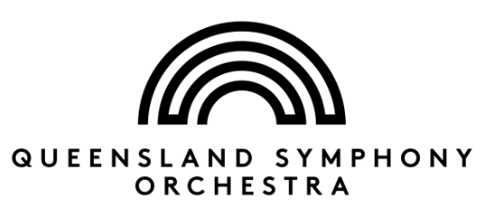
Please send your completed application proposal in writing or email to:

Queensland Symphony Orchestra - Development Department
GPO Box 9994
BRISBANE QLD 4001
Fax: (07) 3833 5001
development@qso.com.au

